

phase2, task3



20f-0197, bse-7A, RIJA ANJUM

I checked my python existence and installed ansible:

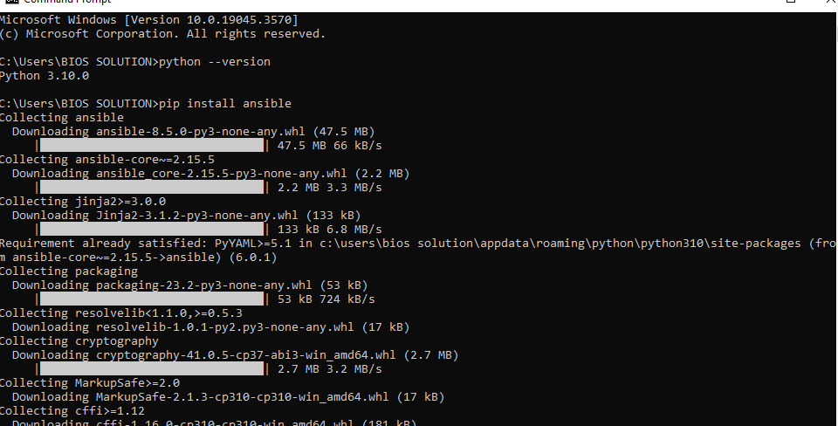

I cloned the project so that same environment can be run for all 3 applications. I used its docker file but made my playbook:

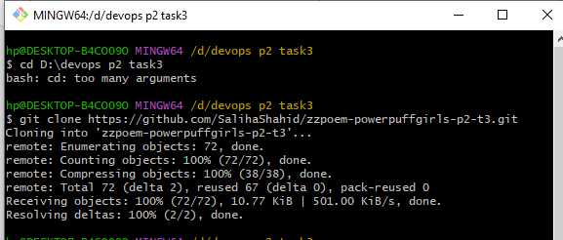

I made my application Vuestorefront branch:

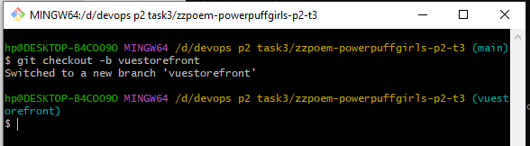

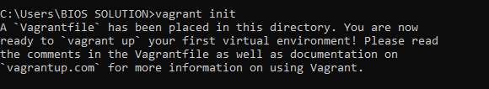

I Vagrant up it and it started running on my oracle virtual box:

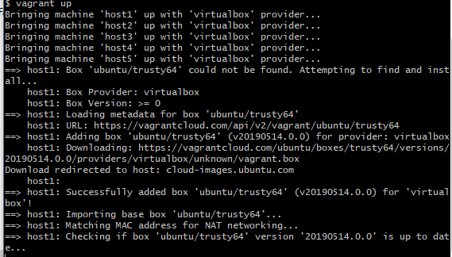

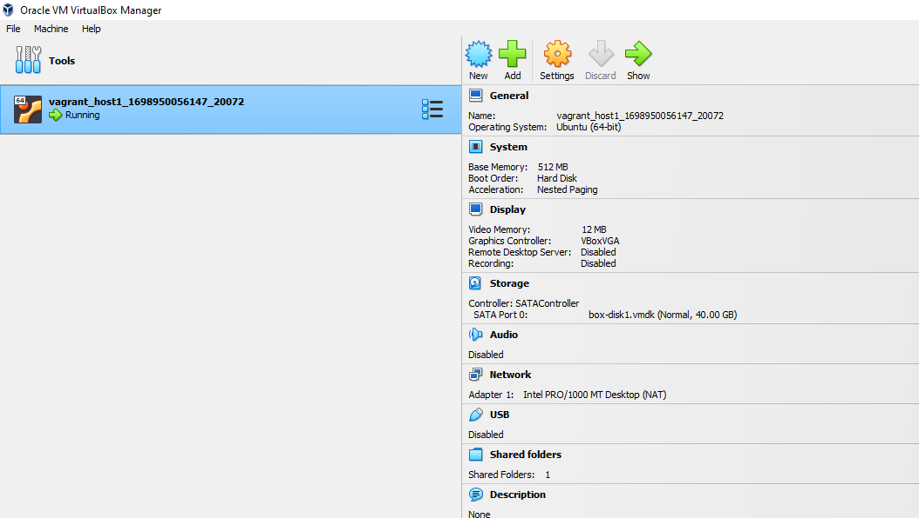

My playbook for Vuestorefront:

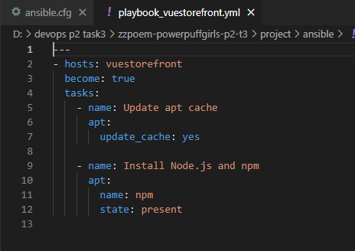

My vagrant file for Vuestorefront:

